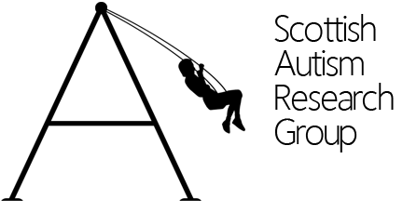
Autism continued…
adulthood and ageing

Friday 26th February 2016

Senate Room, Main Building, University of Glasgow

09.45 | Registration
10.00 | Katie Cebula & Sue Fletcher-Watson: University of Edinburgh  Outcomes from the SARG seminar 2015 and plans for the future
10.20 | Stuart Ritchie: University of Edinburgh  Title tbc
11.00 | Coffee break
11.30 | ‘Research in a Flash’ Talks:  Kabie Brook: Learning about Menopause through the shared experience of autistic people  Asaad Bakshi: title tbc  Ewelina Rydsewska: title tbc  Kirsty Ainsworth: title tbc
12.00 | Jill Ferguson, Val Laurie: Scottish Autism  Peaceful, pain free and dignified: palliative and end of life care for people on the autism spectrum.
12.30 | Lunch
13.45 | Amanda Roestorf: City University, London  Growing Older with Autism Spectrum Disorder: Cognitive Functioning Across the Lifespan
14.25 | Comfort break
14.30 | Pat Howlin: King’s College London  Can we improve outcomes for adults with autism?
15.30 | David Simmons: University of Glasgow  Discussant
16.00 | End

